SQL ANSWERS

- --Row count
SELECT COUNT (*) As Count
FROM FMCG_TABLE;

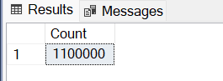

- --Show total units sold in a months
SELECT DATENAME(MONTH,Date)AS Sales_Month,SUM(units_sold)As Total_Units
FROM FMCG_TABLE
GROUP BY DATENAME(MONTH,Date),MONTH(Date)
ORDER BY MONTH(Date) ASC;
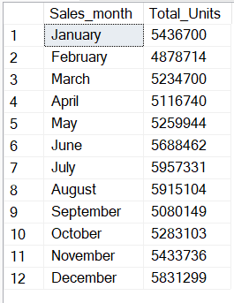
- --Percentage category sold by net_sales
SELECT category,CAST(SUM(net_sales) * 100.0 / (SELECT SUM(net_sales)FROM FMCG_TABLE) AS DECIMAL(10,2)) AS PCT
FROM FMCG_TABLE
--WHERE MONTH(date)=1
GROUP BY category;
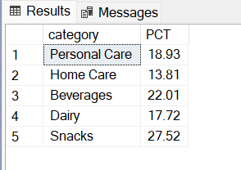

- --Units Sold by channel
SELECT channel,SUM(units_sold) As Unit_sold
FROM FMCG_TABLE
GROUP BY channel
ORDER BY Unit_sold DESC

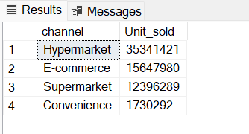

- --Top 5 Countries
SELECT TOP 5 country,SUM(units_sold) As Units_sold
FROM FMCG_TABLE
GROUP BY country
ORDER BY Units_sold DESC

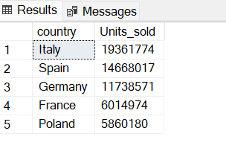

- --Bottom 5 countries
SELECT TOP 5 country,SUM(units_sold) As Units_sold
FROM FMCG_TABLE
GROUP BY country
ORDER BY Units_sold ASC

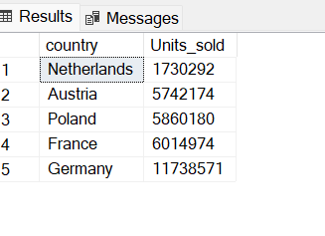

- --Daily trends for orders
SELECT DATENAME(DW,date) AS Order_day,SUM(Units_sold) AS Units_Sold
FROM FMCG_TABLE
GROUP BY DATENAME(DW,date)
ORDER BY CASE DATENAME(DW,date)
WHEN 'Monday' THEN 1
WHEN 'Tuesday' THEN 2
WHEN 'Wednesday' THEN 3
WHEN 'Thursday' THEN 4
WHEN 'Friday' THEN 5
WHEN 'Saturday' THEN 6
WHEN 'Sunday' THEN 7
END

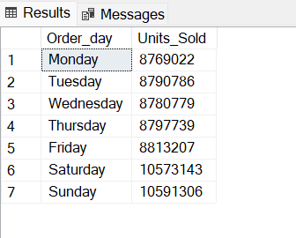

- --Does discount mean higher sales across the brands
SELECT brand,SUM(net_sales) AS Highest_sale,AVG(discount_pct)*100 AS Discount
FROM FMCG_TABLE
GROUP BY brand
ORDER BY Highest_sale DESC;

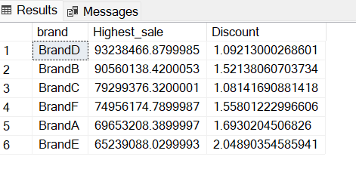

- ---Products with high demand but low stockouts
SELECT
brand,
SUM(units_sold) AS total_demand,
AVG(stock_on_hand) AS avg_stock,
COUNT(CASE WHEN stock_out_flag = 1 THEN 1 END) AS stockout_days,
AVG(lead_time_days) AS avg_lead_time
FROM FMCG_TABLE
GROUP BY brand
ORDER BY
stockout_days DESC,
total_demand DESC;

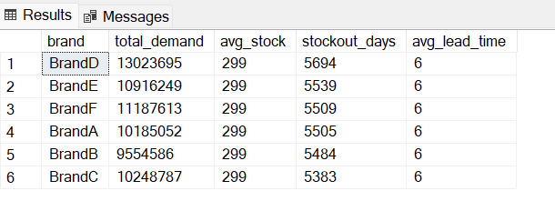

- --Sales by year
SELECT year,FORMAT(SUM(net_sales), 'N0')As Sales
FROM FMCG_TABLE
GROUP BY year
ORDER BY year ASC;

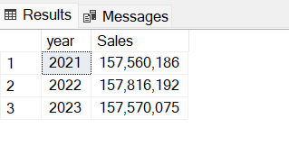

- --Brands with high demand but less stocks
SELECT brand,FORMAT(SUM(units_sold),'N0') AS demand,AVG(stock_on_hand)AS Stock
FROM FMCG_TABLE
GROUP BY brand
ORDER BY demand DESC

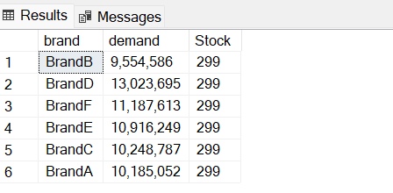

- --How much revenue is potentially lost due to stock-outs?
SELECT
brand,
FORMAT(SUM(list_price * units_sold),'N0') AS potential_lost_revenue
FROM FMCG_TABLE
WHERE stock_out_flag = 1
GROUP BY brand
ORDER BY potential_lost_revenue DESC;

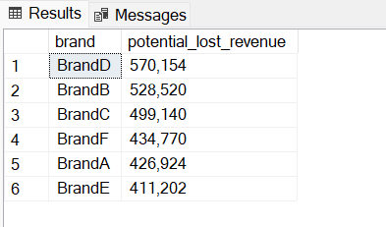

- --Which products frequently run out of stock?

SELECT TOP 5 sku_name,stock_out_flag,COUNT(*) As Stock_out,SUM(units_sold) AS Units_Sold
FROM FMCG_TABLE
WHERE stock_out_flag=1
GROUP BY sku_name,stock_out_flag
ORDER BY Stock_out DESC

